## Introduction

Replas (Recycled Plastic Products) is Australia’s leading plastic recycling product manufacturer. They produce over 200 products from recycled soft plastics and are committed to reducing the amount of plastic currently going to landfill. They have developed world leading technologies to reprocess waste into robust, long-lasting, recycled plastic products for outdoor use. Replas can mix a variety of raw materials to create a large range of colour options.

The products offer an ethical alternative to the unnecessary use of virgin materials and precious natural resources, and provide long-lasting advantages to customers and our environment. The benefits of recycled plastic include: slip-resistance, do not require painting, resistance to termites, microorganisms and moisture, and will never split, rot, crack or need painting.

With more than 25 years of experience, Replas strongly believes it is playing its part towards creating a better environment for the future.

**Some of the most successful Replas products include:**

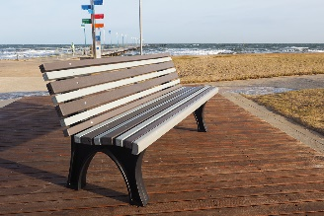 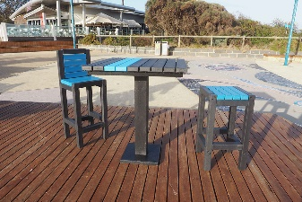 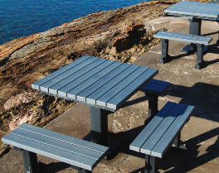 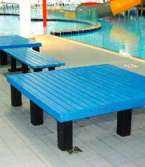

**Benches, Seats and Tables**

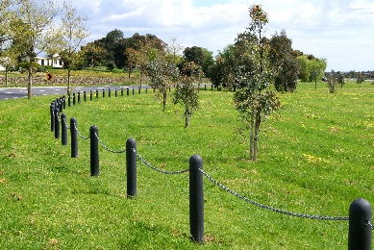 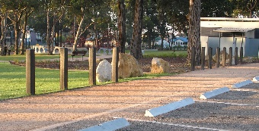 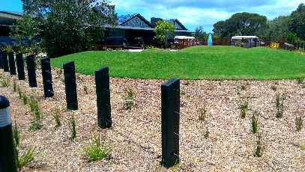 

**Bollards (Posts)**

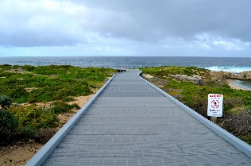 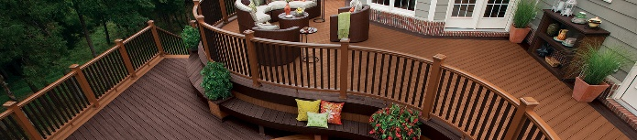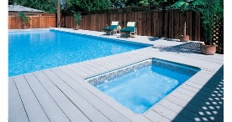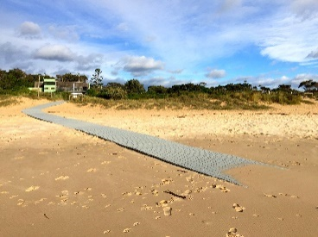

**Deckings, Footbridges & Boardwalks (walkways)**

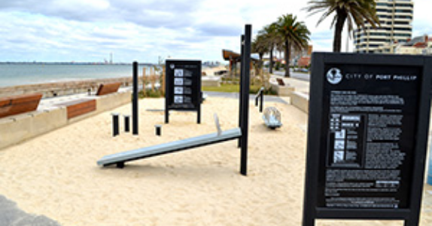 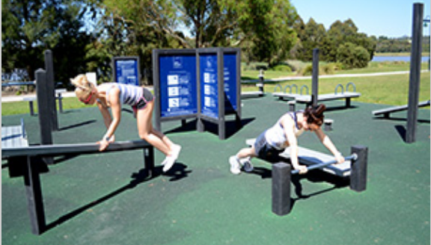 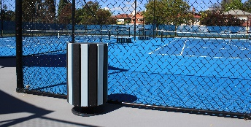

**Exercise Equipment (humans and dogs) Rubbish Bins**

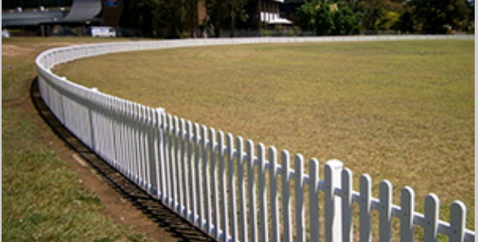 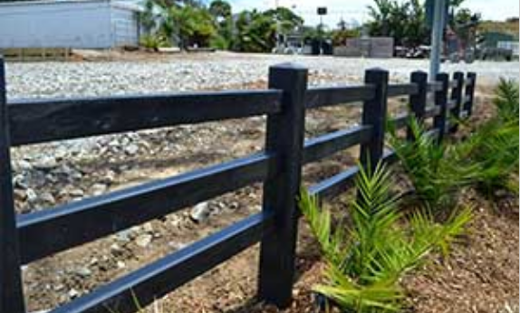 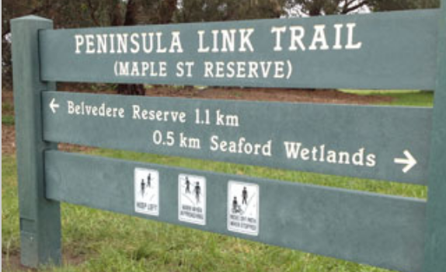 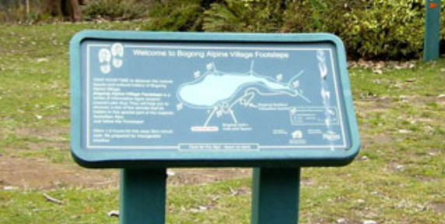

**Fencing Signage**

## Description of project and tasks

Replas have become a far more well-known brand recently due to exposure from a television series regarding the environment. Prior to this, their most common clients were local council and government departments. Their business is expanding and they require a new visual identity that will appeal to a wider audience.

Their target audience will still include local councils and government departments — but will also need to appeal to middle to high income families, as well as international government organisations. All audiences are concerned with the environment and require durable, long lasting products which can endure challenging environments (for example: they may be close to salt water, or in hot climates).

**Tasks:**

1. Create a logo

## Task 1: Create a logo for Replas

**Target audience:**

* Councils and government departments — both nationally and internationally
* Middle to high income families — nationally
* All audiences are concerned with the environment and require durable, long lasting products which can endure challenging environments

## Requirements for Logo:

**Concepts**

Replas would like the following to be incorporated into their logo (and the colours chosen should also convey these concepts):

1. Stability
2. Recycling
3. Environmentally friendly

## Logo Specifications:

The logo should only include the word: **REPLAS** it may include other vector elements  
(The text may be in all caps, lowercase, or with a capital “R”)

Design a full colour, black & white OR greyscale version of the logo.

Note: The logo should NOT include any gradients.

## Logo Variations:

1. Pantone Solid Coated (3-5 colours)
2. CMYK
3. Greyscale OR Black and White

The Pantone Solid Coated and CMYK version should replicate the colours as closely as possible to each other, you should not use colours that cannot be reproduced by another colour gamut (eg: do not choose a fluorescent or metallic Pantone Solid Coated colour).

Include colour swatches in each in the logo versions including the colour specifications of each colour.

CMYK colour values should NOT have decimals (e.g. 2.73%, change to 3%).

## File Type: PDF (Preserve Illustrating Editing Capabilities)

All text must be converted to outlines.   
Trapping: 0.30pt in PMS and CMYK version (if needed)

## FILE Naming

Folder: Logo PMS

File: YY_Replas_Logo_FullColour_PMS.pdf

Folder: Logo CMYK

File: YY_Replas_Logo_FullColour_CMYK.pdf

Folder: Logo Greyscale OR Black & White

File: YY_Replas_Logo_FullColour_Greyscale.pdf or YY_Replas_Logo_FullColour_B&W.pdf

## You must deliver:

1 x A4 printout of the CMYK Logo and Black & White / Greyscale version, mounted on mounting board.   
Size of mounting board max A3. Ensure that you include your name of the front of the board.

3 x PDF files